# BOOMER BALL

A MINI-PROJECT REPORT

*Submitted by*

ASHWIN SHA K 211701501

PRITHIK VAJAN A 211701039

*in partial fulfillment for the course*

### CD19651 – MINI PROJECT

*for the degree of*

**BACHELOR OF ENGINEERING**

### in

**COMPUTER SCIENCE AND DESIGN**

RAJALAKSHMI ENGINEERING COLLEGE RAJALAKSHMI NAGAR

THANDALAM CHENNAI – 602 105

MAY 2024

# RAJALAKSHMI ENGINEERING COLLEGE CHENNAI - 602105

## BONAFIDE CERTIFICATE

Certified that this project report **“BOOMER BALL”** is the bonafide work of **“ASHWIN SHA K (211701501) & PRITHIK VAJAN A (211701008)”** who carried out the project work for the subject CD19651- Mini Project under my supervision.

|  |  |
| --- | --- |
| **SIGNATURE**  **Prof. Uma Maheshwar Rao , Head of the Department** Associate Professor  Department of Computer Science and Design  Rajalakshmi Engineering College  Chennai - 602105 | **SIGNATURE**  **Mr. Gunasekar S, M.Tech.,(Ph.D)., Supervisor**  Assistant Professor (SG)  Department of Computer Science and Design  Rajalakshmi Engineering College  Chennai - 602105 |

Submitted to Project and Viva Voce Examination for the subject CD19651- Mini Project held on .

Internal Examiner External Examiner

### ABSTRACT

"Boomer Ball" is an immersive and meticulously crafted high-quality 2D platformer featuring Boomer, a brave and adventurous bear. The game transports players into a lush, hand-drawn forest where Boomer embarks on a quest to reclaim his stolen honey from mischievous forest creatures.

Inspired by the beloved mechanics of classic platformers like Mario, "Boomer Ball" emphasizes tight controls and precise jumping, allowing players to experience a seamless and responsive gameplay environment. The world is filled with dynamic obstacles, notably magical mushrooms that present unique challenges—some grow instantaneously to block paths, others release spore clouds that obscure vision or create slippery surfaces.

Players navigate treacherous terrain, avoid pitfalls, and outsmart enemies while collecting honeycombs that encourage exploration and reward players with bonuses. Hidden secrets and alternate routes add depth, inviting replayability to discover all the forest's hidden wonders.

With vibrant colors, detailed animations, and an enchanting soundtrack, "Boomer Ball" creates a captivating atmosphere. It combines the nostalgic charm of classic platformers with innovative mechanics and a rich, visually appealing world, offering a challenging yet accessible adventure for both seasoned gamers and newcomers. Players will be drawn into Boomer's quest, compelled by engaging challenges and enchanted by its charming presentation.

# ACKNOWLEDGEMENT

Initially we thank the Almighty for being with us through every walk of our life and showering his blessings through the endeavour to put forth this report. Our sincere thanks to our Chairman **Mr.S.Meganathan, B.E, F.I.E.,** our Vice Chairman **Mr. Abhay Shankar Meganathan, B.E., M.S.,** and our respected Chairperson **Dr. (Mrs.) Thangam Meganathan, Ph.D.,** for providing us with the requisite infrastructure and sincere endeavouring in educating us in their premier institution.

Our sincere thanks to **Dr. S.N.Murugesan, M.E., Ph.D.,** our beloved Principal for his kind support and facilities provided to complete our work in time. We express our sincere thanks to our **Prof. Uma Maheshwar Rao** Associate Professor and Head of the Department of Computer Science and Design for his guidance and encouragement throughout the project work. We convey our sincere thanks to our internal guide and Project Coordinator, **Mr.S.Gunasekar, M.Tech., (PhD).,** Department of Computer Science and Design, Rajalakshmi Engineering College for his valuable guidance throughout the course of the project.

ASHWIN SHA K (211701501)

PRITHIK VAJAN A (211701039)

**TABLE OF CONTENTS**

**CHAPTER NO. TITLE PAGE NO.**

|  |  |
| --- | --- |
| **ABSTRACT** | **iii** |
| **LIST OF FIGURES** | **vi** |
| **1. INTRODUCTION** | **7** |
| 1.1 OUTLINE | 7 |
| 1.2 OBJECTIVE | 8 |
| 1.3 EXISTING SYSTEM | 10 |
| 1.4 PROPOSED SYSTEM | 11 |
| **2. LITERATURE REVIEW** | **13** |
| **3. GAME DESIGN** | **15** |
| 3.1 GAME FLOW DIAGRAM | 15 |
| 3.2 GAME STAGES | 16 |
| **4. PROJECT DESCRIPTION** | **18** |
| 4.1 MODULES | 18 |
| **5. OUTPUT SCREENSHOTS** | **19** |
| **6. CONCLUSION** | **24** |
| **REFERENCES** | **25** |

**LIST OF FIGURES**

|  |  |  |
| --- | --- | --- |
| **Figure No** | **Figure Name** | **Page No.** |
| 5.1 | Login Screen | 19 |
| 5.2 | Landing Page | 19 |
| 5.3 | Collectibles in the game | 20 |
| 5.4 | Obstacles in the game | 20 |
| 5.5 | Discovering New Place | 21 |
| 5.6 | Obstacles in the place | 21 |
| 5.7 | Exit Of New Place | 22 |
| 5.8 | Obstacles for collecting super coin | 22 |
| 5.9 | Finishing Point For the Game | 23 |
| 5.10 | Game Over Page | 23 |

# CHAPTER 1

### OUTLINE

The exploits of Boomer, a courageous bear on a mission to recover his stolen honey amid a gorgeous, hand-drawn forest, are chronicled in the excellent 2D platformer "Boomer Ball". Smooth and entertaining gameplay is offered by the game's precise jumping mechanics and snappy, responsive controls, which are reminiscent of vintage platformers like Mario. Gamers guide Boomer through more difficult stages that are full of dynamic obstacles, mostly magical mushrooms that provide special difficulties like spore clouds obstructing visibility, slippery surfaces, and quick growth blocking routes.

The levels are designed to be complex and varied, with lively, interesting surroundings that promote exploration. A further element of complexity and reward is added by the honeycombs that are strewn throughout and that players may gather for bonuses and power-ups. The levels' replay ability is increased with different paths and hidden surprises, which entice players to explore all the forest's hidden treasures.

The style of "Boomer Ball" adds to the film's visual appeal with vivid colors and intricate animations that bring the forest and its creatures to life. The captivating soundtrack evokes a sense of wonder and takes players into Boomer's world in harmony with the graphics. The game is appropriate for both novices and experienced players since it strikes a balance between difficulty and accessibility. Boomer's Quest's captivating plot and the game's endearing graphics make for an emotionally rich and satisfying experience. "Boomer Ball" is a gripping and enjoyable experience that appeals to a wide audience by fusing vintage

Features.

* 1. **OBJECTIVE**

The primary objective of the "Boomer Ball" project is to develop a high-quality 2D platformer that combines the nostalgic charm of classic games like Mario with innovative gameplay mechanics and a richly detailed, hand-drawn art style. The project aims to create an engaging, challenging, and visually captivating experience for a broad audience of both seasoned gamers and newcomers, The Following Key Objectives as follows:

* + 1. **Engaging Gameplay Experience:** Ensure that players enjoy a seamless and responsive gameplay environment by providing tight, responsive controls and precise jumping mechanics. The game will draw inspiration from classic platformers, offering yet finely-tuned gameplay that is both accessible and rewarding.
    2. **Challenging and Dynamic Obstacles:** Design dynamic and varied obstacles to maintain player interest and challenge. The game will feature magical mushrooms as primary adversaries, each type presenting unique challenges such as instant growth blocking paths, spore clouds that obscure vision, and slippery surfaces that require navigation.
    3. **Visually Appealing World:** Create a richly detailed and visually stunning world with hand-drawn art that captures the lush, vibrant forest setting. Each level will be meticulously designed to enhance the player’s immersion and provide a visually cohesive experience.
    4. **Immersive Atmosphere:** Complement the detailed visual design with an enchanting and immersive soundtrack. The music will be carefully crafted to enhance the game’s atmosphere, making the player’s journey through Boomer’s World more engaging and memorable.
    5. **Broad Appeal Accessibility:** Balance the game’s difficulty to ensure it is accessible to newcomers while still offering a satisfying challenge for seasoned games. The game will be designed to be easy to pick up but difficult to master, appealing to a wide audience.
    6. **Exploration and Replayability:** Encourage players to explore and replay the game by incorporating hidden secrets and alternate routes with each level. This design choice will provide a sense of discovery and long term engagement, rewarding players for through exploration and repeated playthroughs.
    7. **Rich and Detailed Level Design:** Ensure each level is intricately designed to provide a variety of challenges and visual experiences. Levels will be crafted to encourage players to experiment with different strategies and paths, enhancing replayability.
    8. **Rewarding Collectibles:** Scatter of Coins Throughout the game, which can gather for bonuses. These will add depth to gameplay, offering additional objectives and enhancing Boomer’s abilities to help him on his quest.

By achieving these objectives, "Boomer Ball" aims to deliver a nostalgic yet innovative platforming experience that captivates players with its engaging gameplay, charming storyline, and visually stunning world.

### EXISTING SYSTEM

The "Boomer Ball" project draws inspiration from a long tradition of platformer game called Super Mario Bros., particularly those with a strong emphasis on tight controls, precise mechanics, and engaging level design. This section outlines the key elements of existing platformer games that inform the development of "Boomer Ball. Here's how existing systems related to each aspect might look like:

### Classic Platformer Mechanics:

Classic platformers like Super Mario Bros. serve as the foundation for ”Boomer Ball”. These games are renowned for their tight controls and precise mechanics. Hidden areas and collectibles scattered throughout the levels provide incentives for exploration and replayability, rewarding players for through exploration and skillful play.

### Visual and Audio Design:

The Visuals and Audio design of platformers plays a crucial role in enhancing the player experience. Games like Rayman and Ori and the Blind Forest feature distinct are styles characterized by hand drawn elements and vibrant colors. Similarly, a captivating soundtrack that complements the game’s theme and atmosphere enhances the player’s emotional connection to the game, as seen in titles like Hollow Knight.

### Limitations and Challenges:

Despite these advancements, traditional platformers often follow a linear progression, limiting the sense of exploration and discovery. Modern games are increasingly incorporating open world elements or multiple paths within levels to address limits.

### PROPOSED SYSTEM

The proposed system for "Boomer Ball" aims to combine the nostalgic elements of classic platformers with innovative gameplay mechanics and modern design elements. This section outlines the key features and components of the proposed system. Here's a detailed description of the proposed system:

### Tight Controls and Precise Mechanics:

Implement responsive controls and precise jumping mechanics reminiscent of classic platformers like Super Mario Bros. Ensure that player movements are intuitive and accurate, enhancing the overall gameplay experience.

### Engaging Level Design:

### Design levels that progressively increase in difficulty, introducing new obstacles and mechanics as players advance. Incorporate hidden secrets, alternate paths, and interactive elements to encourage exploration and replayability.

### 1.4.3. Immersive Art Style and Visuals:

### Develop a richly detailed, hand drawn art style with vibrant colors and charming character designs. Create visually stunning environments that bring the forest setting to life and captivate players from start to finish.

### Captivating Soundtrack:

### Compose an enchanting soundtrack that complements the game’s atmosphere and enhances the player’s emotional engagement. Use thematic music and sound effects to create cohesive audio experience that immerses players in Boomers’s world

### Dynamic Obstacles and Challenges:

### Introduce a variety of dynamic obstacles and challenges throughout the game, including magical mushrooms with unique properties. These obstacles will test the player’s reflexes and problem solving skills adding depth and complexity to the gameplay.

### Narrative Integration:

### Craft a compelling storyline centered around Boomer the bear's quest to reclaim his stolen honey. Integrate narrative elements seamlessly into the gameplay, providing context and motivation for players as they progress through the game.

### Accessibility ad Replayability:

### Balance the game's difficulty to accommodate both seasoned gamers and newcomers. Provide multiple difficulty settings or adaptive gameplay mechanics to ensure accessibility for players of all skill levels. Additionally, incorporate hidden secrets, collectibles, and achievements to encourage replayability and long-term engagement.

### Innovative Mechanics and Modern Design Elements:

### Introduce innovative gameplay mechanics and modern design elements to differentiate "Boomer Ball" from traditional platformers. Experiment with new ideas such as environmental interactions, character abilities, and dynamic level elements to create a fresh and unique gameplay experience.

## CHAPTER 2 LITERATURE REVIEW

The development of "Boomer Ball" draws upon a rich history of platformer games and relevant research in game design, user experience, and player engagement. This literature review examines key studies, articles, and game analyses that inform the design and development of "Boomer Ball.":

### Classic Platformer Mechanics:

* + - Classic platformer games, such as Super Mario Bros., have been extensively studied for their gameplay mechanics and level design principles. Research by Kearsley and Voci (2019) emphasizes the importance of tight controls and precise jumping mechanics in creating an enjoyable player experience. Additionally, Deterding et al. (2016) discuss the significance of progressive difficulty curves and player feedback in maintaining player engagement throughout the game.

### Visual and Audio Design in Games:

* + - The visual and audio design of games play a crucial role in shaping the player experience. Studies by Chen et al. (2020) and Mirza-Babaei et al. (2015) highlight the impact of art style, color palette, and animation quality on player immersion and enjoyment. Furthermore, Boyle et al. (2012) emphasize the importance of thematic music and sound effects in enhancing the emotional resonance of games and reinforcing the game's atmosphere.

### Modern Innovations in Platoformers:

* + - Contemporary platformer games often incorporate innovative mechanics and design elements to differentiate themselves from classic titles. Research by Riggan et al. (2018) explores the use of procedural level generation and adaptive difficulty systems to increase player engagement and replayability. Additionally, Hunicke et al. (2004) propose the Mechanics-Dynamics-Aesthetics (MDA) framework for game design, which emphasizes the importance of balancing game mechanics, player interactions, and emotional experiences.

### Narrative Integration and Player Engagement:

* + - Narrative integration is a key aspect of many successful platformer games, enriching the player experience and providing context for gameplay mechanics. Studies by Taylor (2002) and Gee (2003) explore the role of storytelling in games and its impact on player engagement and motivation. Additionally, Murray (1998) discusses the concept of "agency" in games, highlighting the importance of player autonomy and decision-making in creating meaningful gameplay experiences.

The literature review provides valuable insights into the design principles, mechanics, and player engagement strategies employed in platformer games. By drawing upon these findings, the development team behind "Boomer Ball" can create a game that combines the best elements of classic platformers with modern innovations, immersive visuals, and engaging storytelling. Additionally, research on player engagement and narrative integration informs the design of "Boomer Ball," ensuring that it delivers a compelling and memorable experience for players of all ages.

## CHAPTER 3 GAME

**DESIGN**

### USER FLOW DIAGRAM

The user flow for "Boomer Ball" outlines the sequence of actions and interactions that players will experience as they navigate through the game. This flow ensures a seamless and intuitive gameplay experience, guiding players from the initial start screen to the completion of a level.

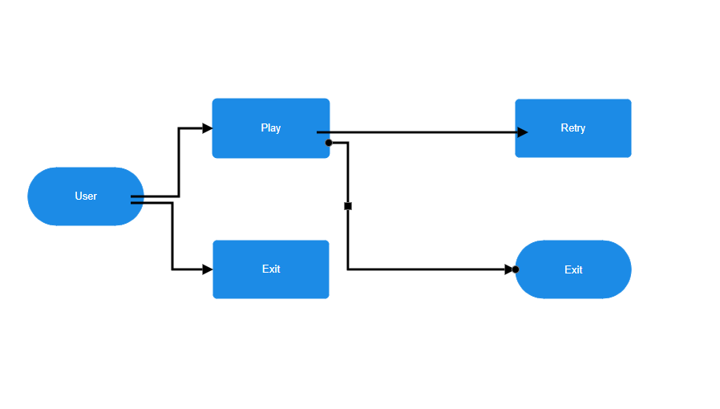

Fig 3.1 User Flow Diagram

## APPLICATION STAGES

### EMPATHIZE

The empathize stage of the design process for “Boomer Ball” Involves understanding the needs, preferences, and expectations of the target audience players who enjoy platformer games and empathizing with their experience to inform the game’s development. This stage is essential for creating a game that resonates with players and provides a fulfilling gameplay experience.

### DEFINE

In the define stage of the design process for “Boomer Ball,” the focus shifts from understanding the needs and preferences of the target audience to defining specific goals, requirements and design principles for the game. This lays the foundation for the development process by establishing clear objectives and guiding that will inform the creation of “Boomer Ball’.

### IDEATE

The ideate stage of the design process for “Boomer Ball” focuses on generating creative ideas and solutions to address the defined goals and requirements established in the previous stages. This stage encourages exploration, experimentation, and innovation to conceptualize the key features, mechanics and visual elements that will define the game.

### PROTOTYPE

The Prototype stage of the development process for “Boomer Ball” focuses on creating tangible representations of the game’s key features, mechanics and visual elements. Prototypes allow the development team to test and iterate on different concepts, gather feedback, and refine the game’s design before moving into full scale production. This stage is crucial for validating ideas, identifying potential issues and ensuring that the final game meets the defined goals and requirements.

### TEST

The Test stage of the development process for “Boomer Ball” is essential for ensuring the game’s quality, stability and performance before its release to the public. This stage involves rigorous testing and debugging to identify and address any issues or bugs that may impact the player experience. The test stage encompasses various types of testing, including functional testing, usability testing, performance testing and compatibility testing.

## CHAPTER 4 PROJECT DESCRIPTION

### MODULES

“Boomer Ball” is a captivating 2D platformer game that immerses players in a thrilling adventure through vibrant and immersive worlds.

### Gameplay Mechanics:

* + - * Tight controls and precise mechanics reminiscent of classic platformer games like Super Mario Bros.
      * Innovative gameplay mechanic: Boomer can transform into a rolling ball, when the player gets out.

### Dynamic Levels and Obstacles:

* + - * Engaging level design filled with dynamic obstacles, magical mushrooms and hidden secrets.
      * Encounter various enemies and environmental hazards, requiring quick reflexes and strategic thinking to overcome.
      * Notifications: Display relevant notifications about order updates, new government schemes, and promotions.

### Visual Value and Customizations:

* + - * Hidden secrets, collectibles and alternate paths to discover in each level and also compete for high scores, unlock achievements.

## CHAPTER 5 OUTPUT SCREENSHOTS

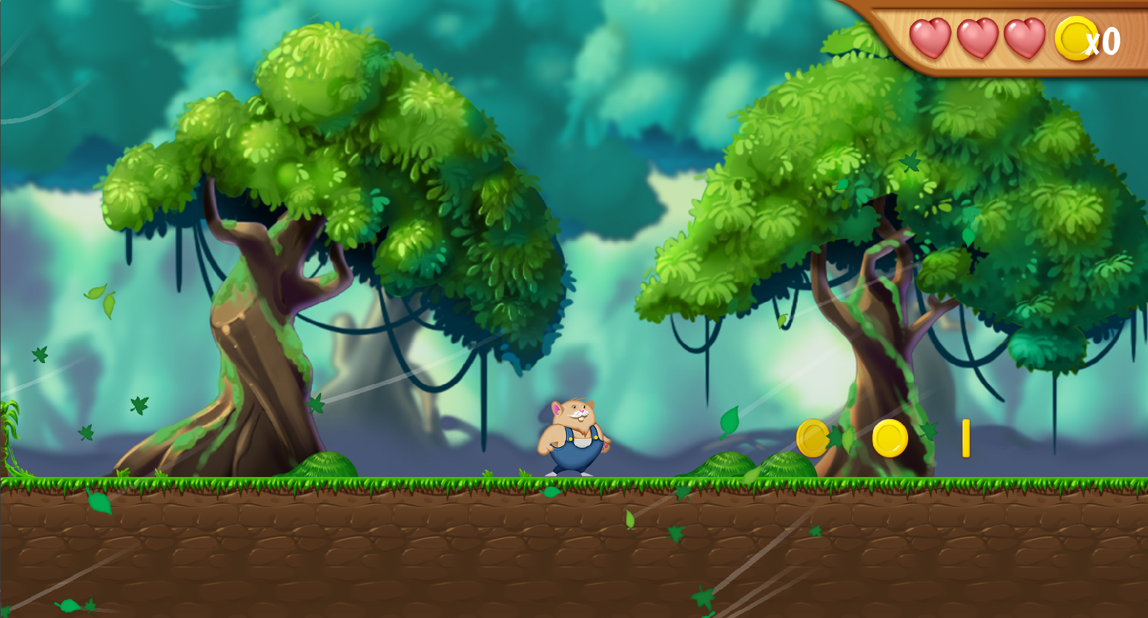Fig 5.1 Login Screen

Fig 5.2 Landing Page

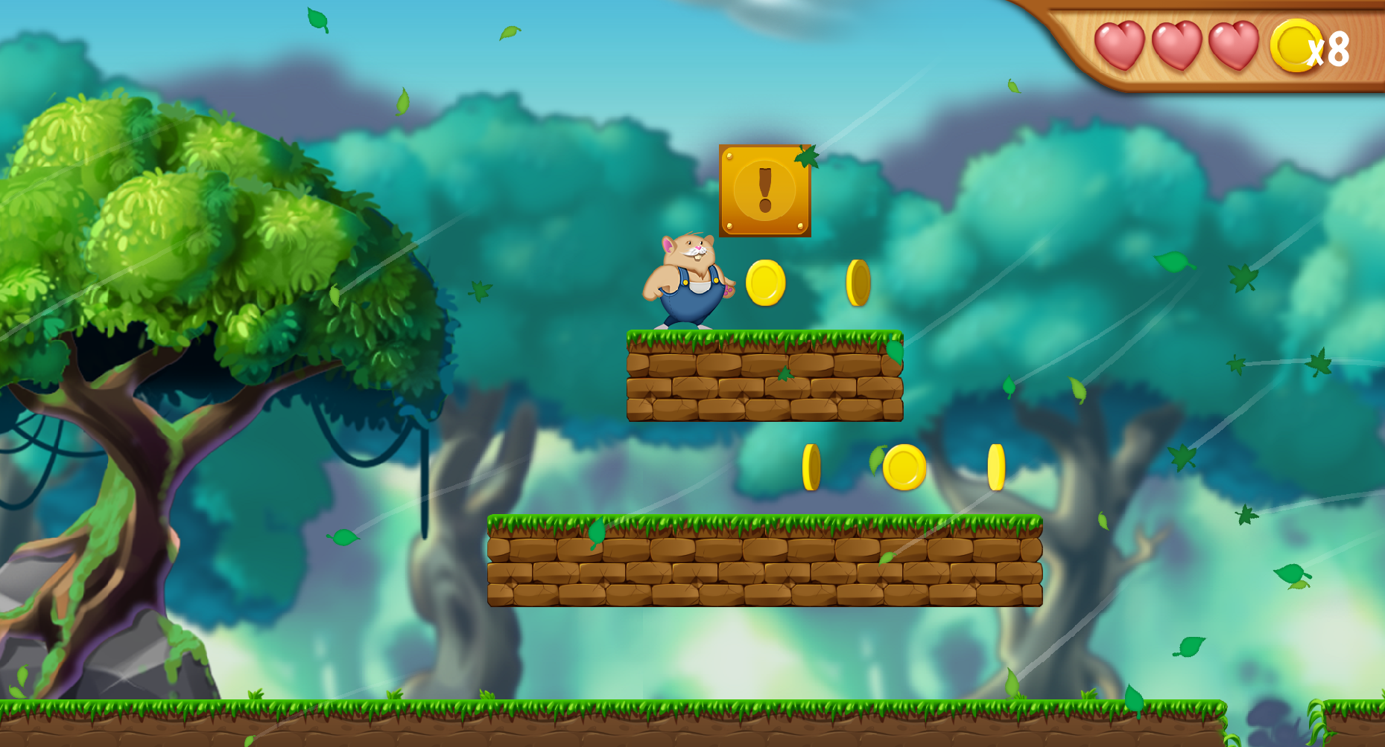

Fig 5.3 Collectibles In The Game

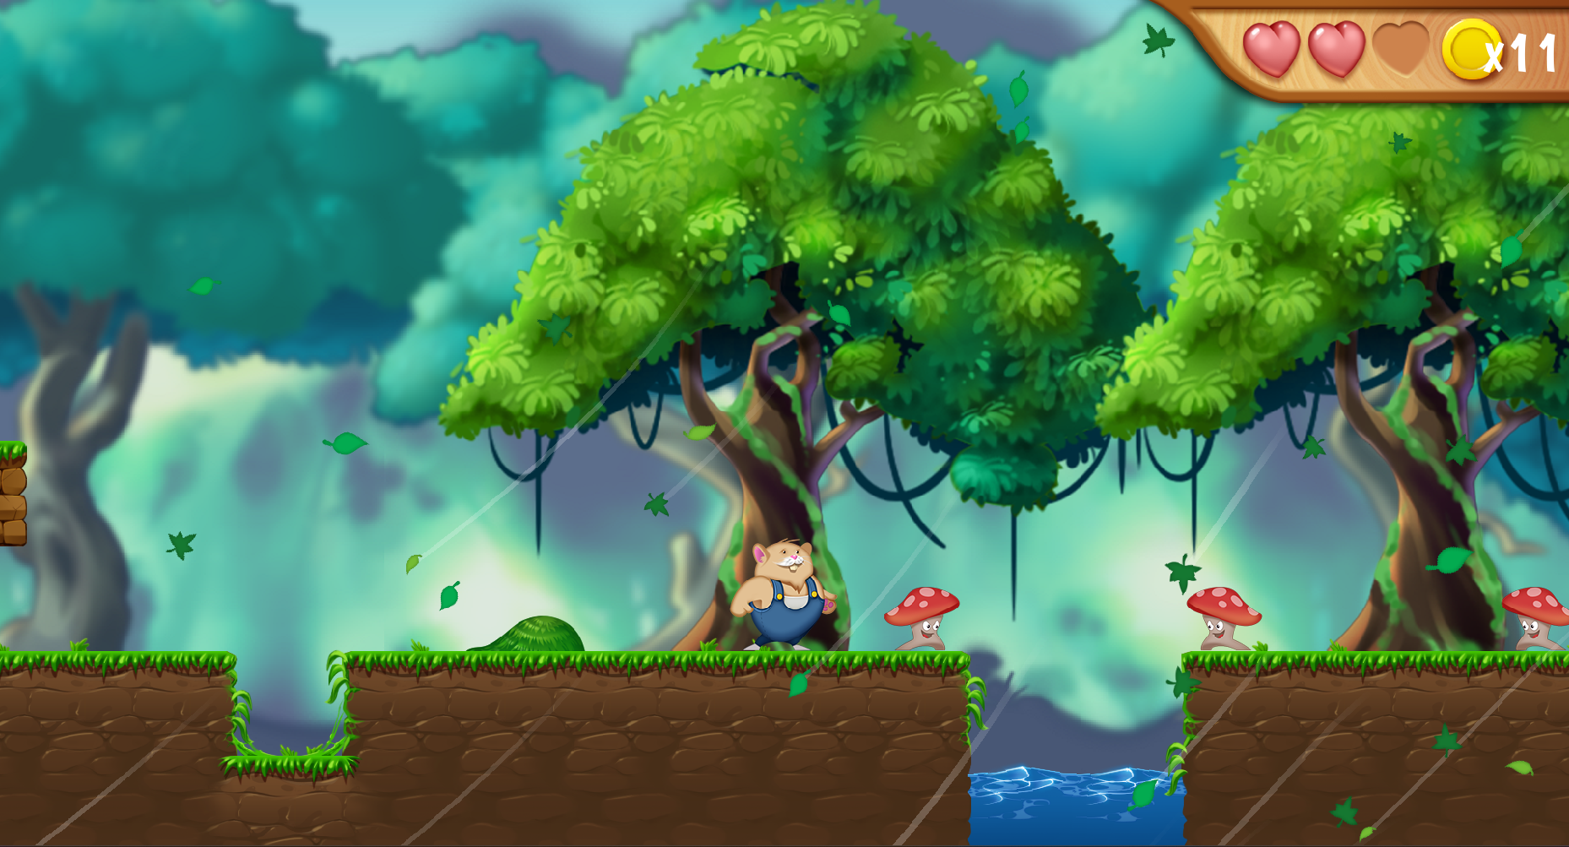

Fig 5.4 Obstacles in the game

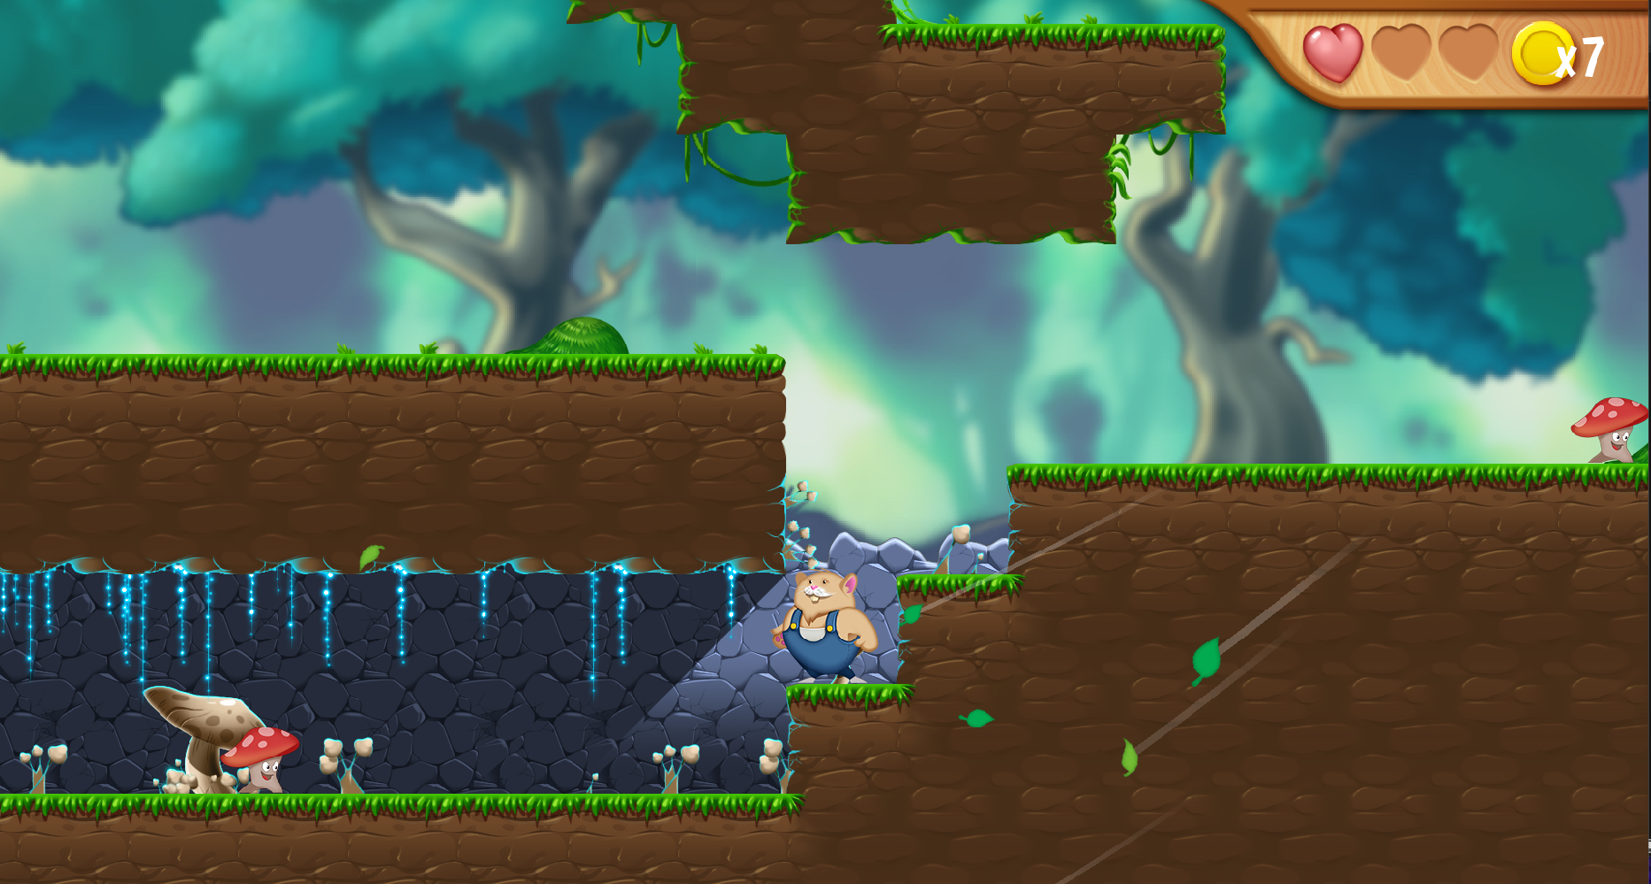

Fig 5.5 Discovering New Place

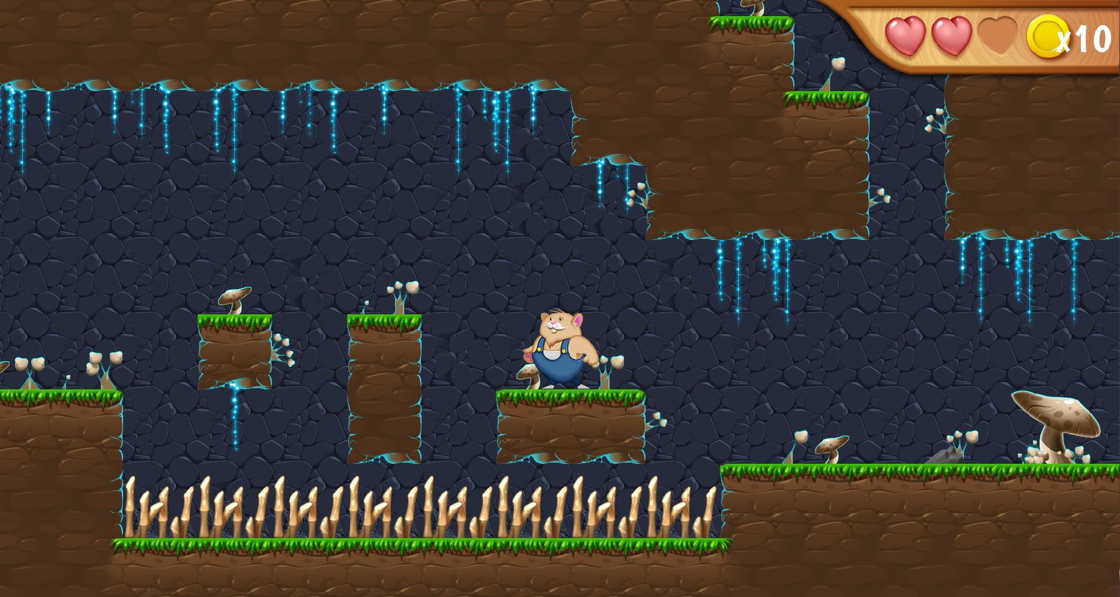

Fig 5.6 Obstacles in The Place

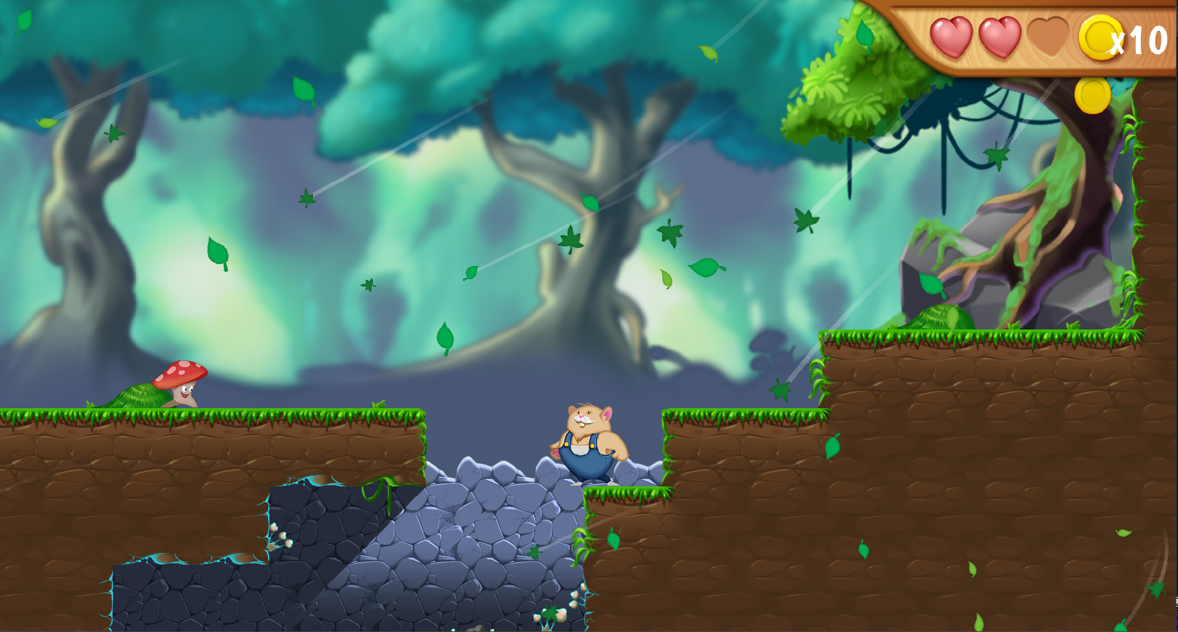

Fig 5.7 Exit of New Place

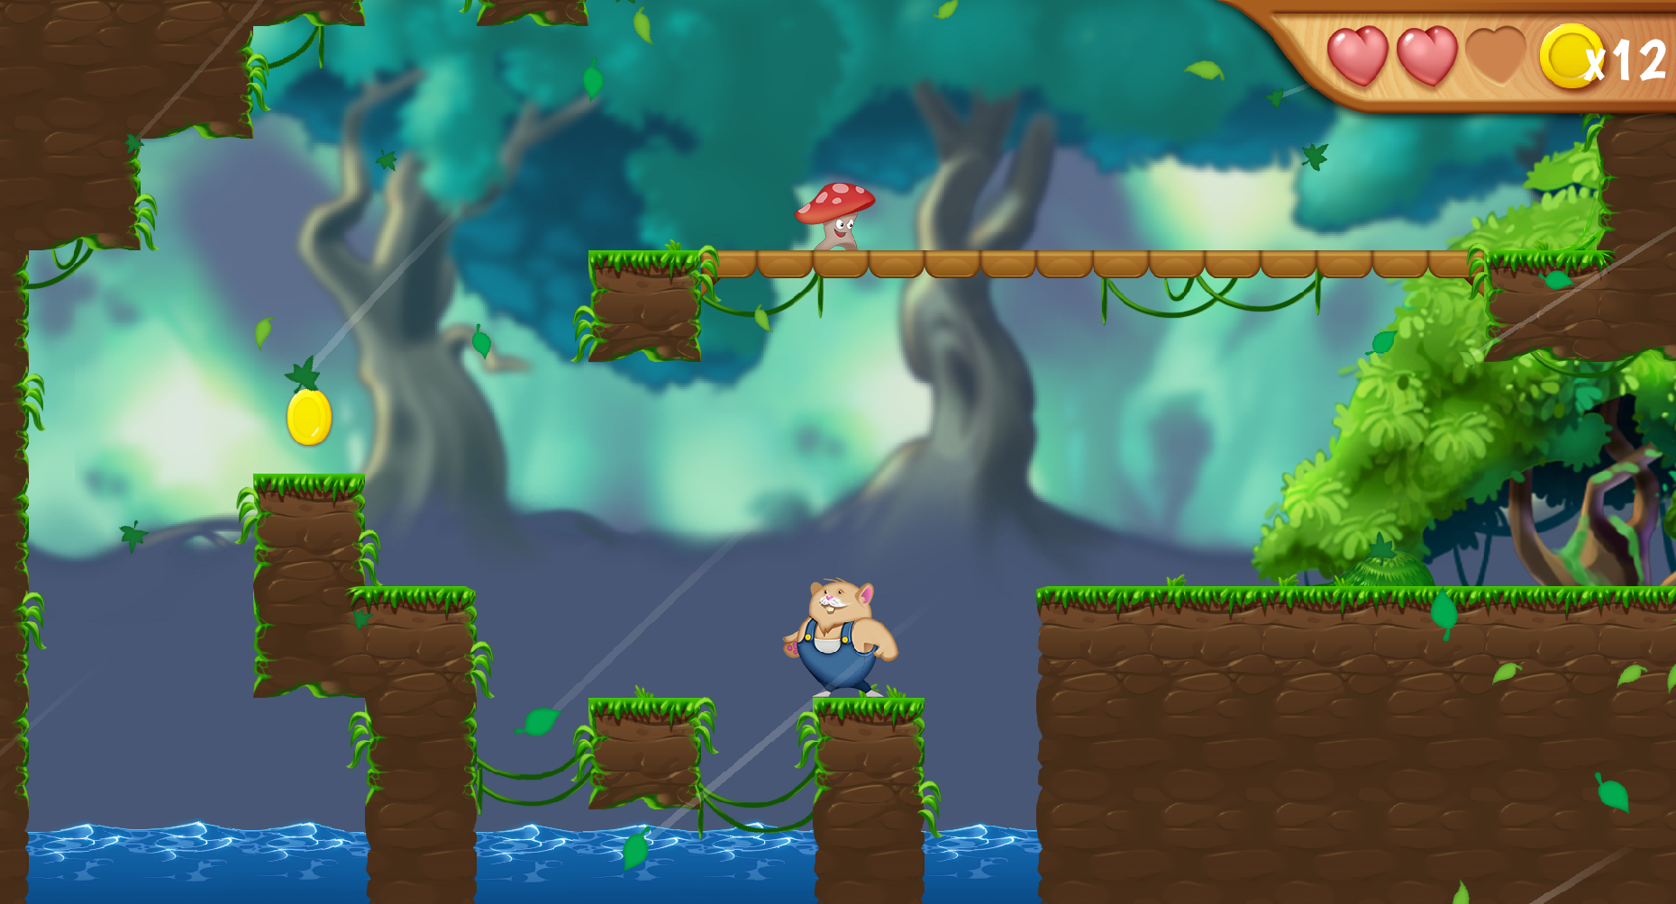

Fig 5.8 Obstacles for Collecting Super Coin

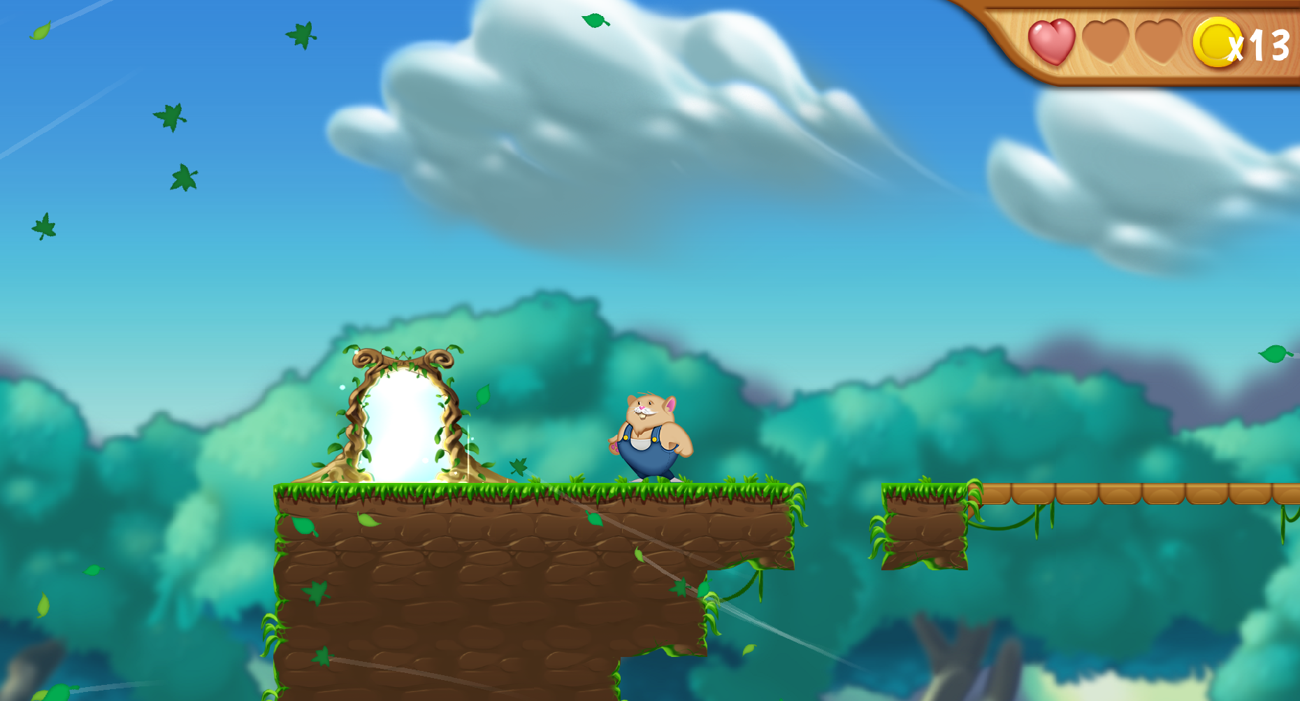

Fig 5.9 Finishing Point For Game

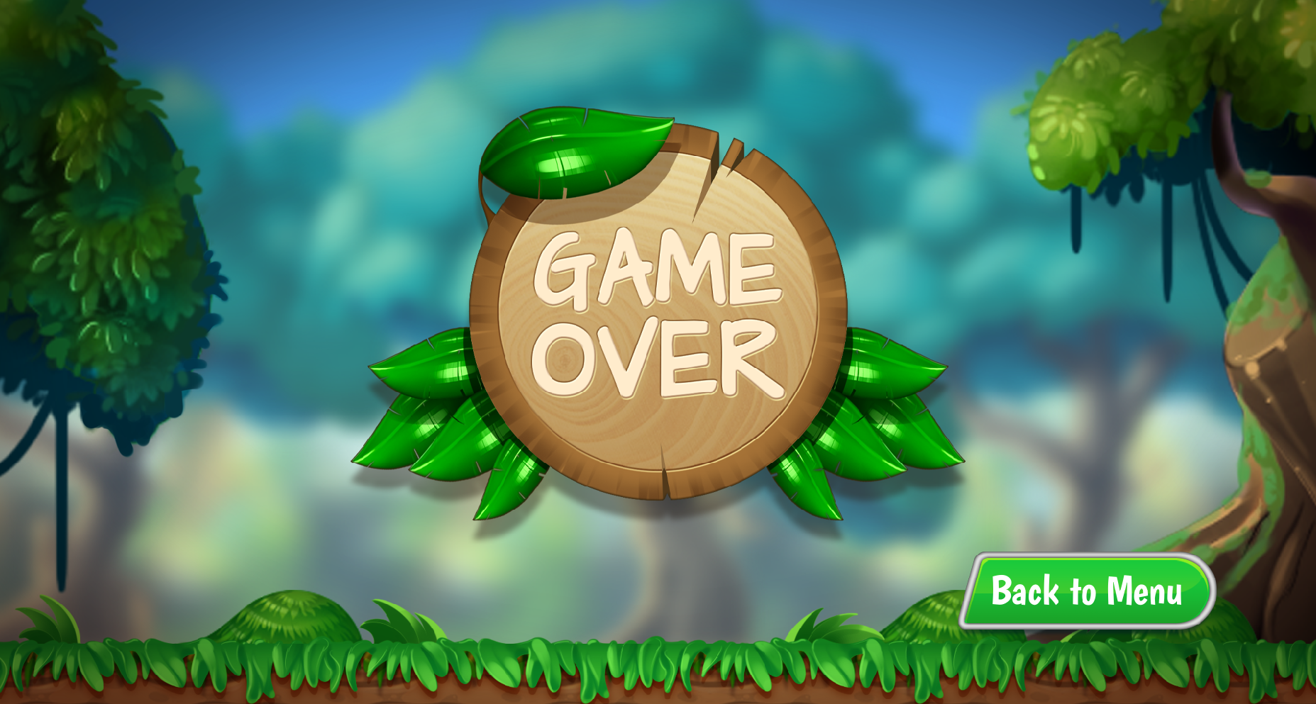

Fig 5.10 Game Over Page

## CHAPTER 6 CONCLUSION

"Boomer Ball" offers a captivating blend of classic platforming action, innovative gameplay mechanics, and charming visual design that promises to captivate players of all ages. With tight controls, dynamic levels, and the unique ability for Boomer to transform into a rolling ball, players will embark on an exhilarating adventure filled with challenges and excitement.

The stunning hand-drawn art style, vibrant colors, and enchanting soundtrack create an immersive experience that brings the world of Boomer to life. Whether exploring lush forests, scaling snowy mountains, or delving into mysterious caves, players will be drawn into a visually captivating world teeming with life and adventure.

"Boomer Ball" doesn't just offer a thrilling gameplay experience; it also provides plenty of replay value and customization options. With hidden secrets to uncover, collectibles to find, and achievements to unlock, players can embark on endless adventures and tailor their experience to suit their preferences.

In conclusion, "Boomer Ball" promises to deliver hours of fun and excitement for players of all skill levels. Join Boomer on his epic quest to reclaim his stolen honey and experience the thrill of rolling, jumping, and smashing your way to victory in this delightful 2D platformer.

## REFERENCES

1. "The Anatomy of a Platformer" by Mark Brown: **“https://www.youtube.com/watch?v=216_5nu4aVQ”**
2. “Designing 2D Platformers: A Comprehensive Guide" by Gamdev Academy: **“https://www.youtube.com/watch?v=ZH2wGpEZ**